Containerization and Container Orchestration – Shopnow app

Implementation Steps:
Step 1: Version Control with Git
Step2 : Create and pushed docker images to Amazon ECR
Private repositories created in Amazon ECR
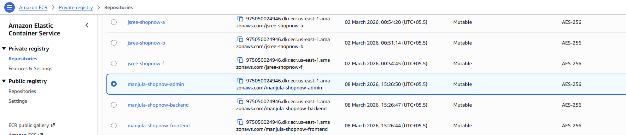

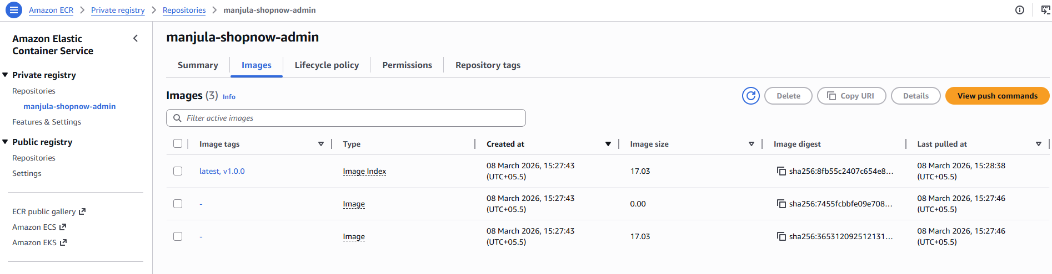

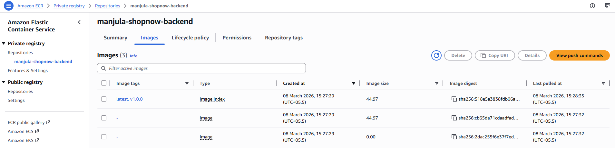
Step 4: Continuous Integration (CI) using Jenkins
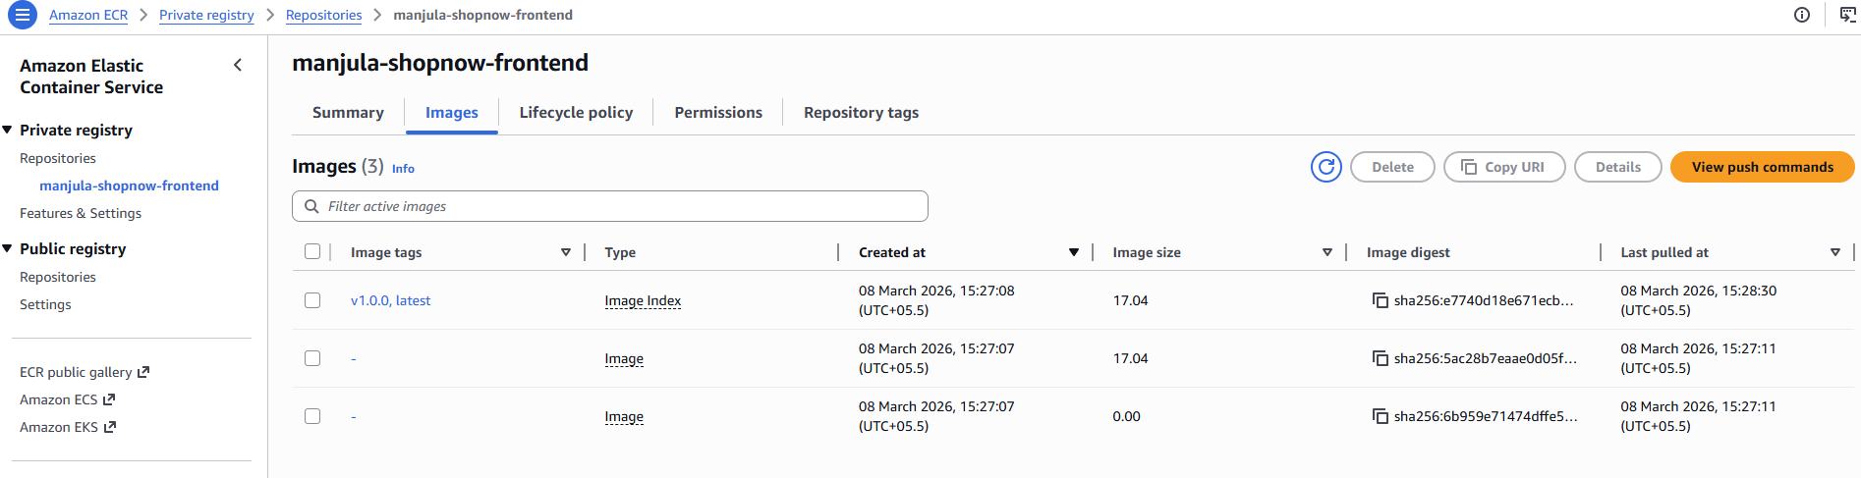

Running the app using docker 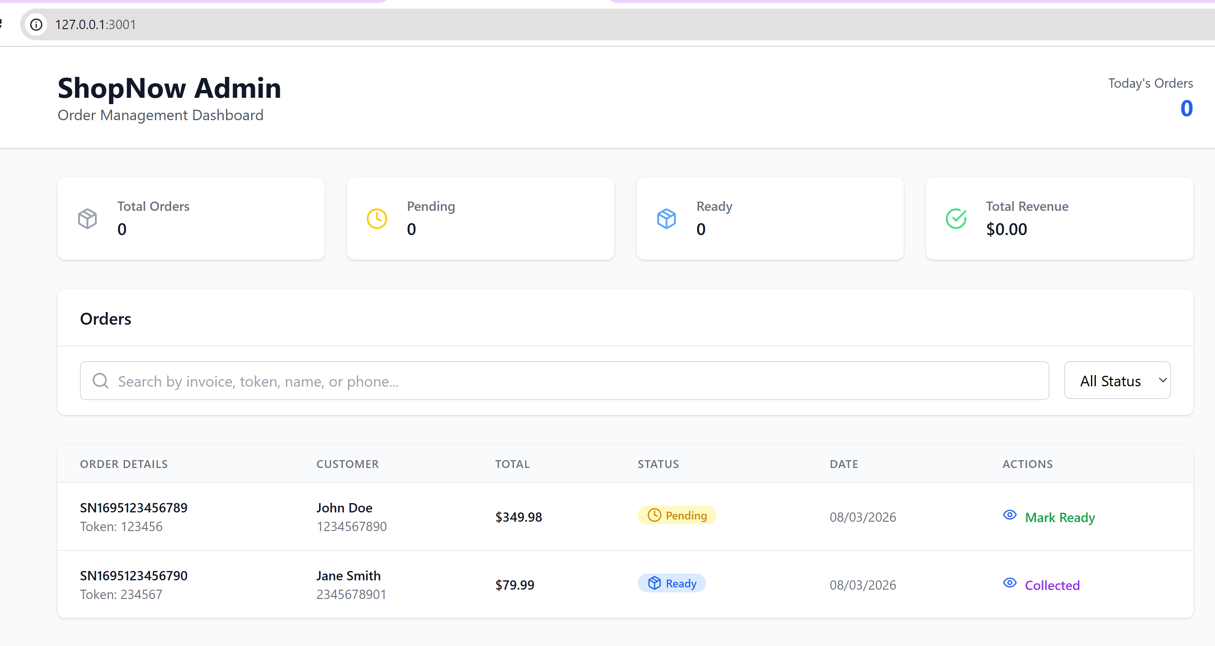

Health check of the App
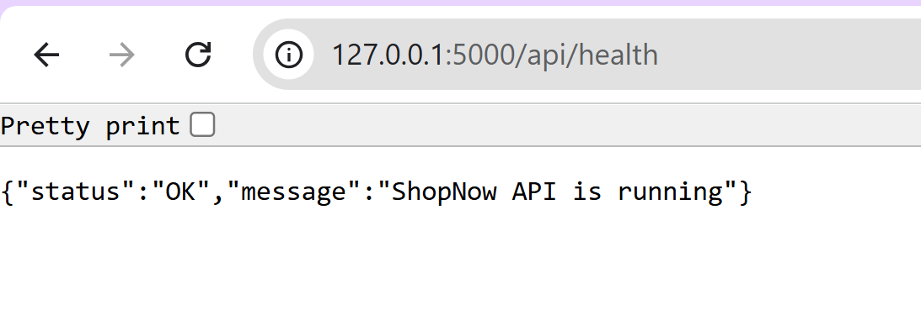
Step 4: Continuous Integration (CI) using Jenkins
CI/CD Pipeline
- GitHub → webhook triggers Jenkins → builds Docker images → pushes to Amazon ECR → Helm deploys to EKS

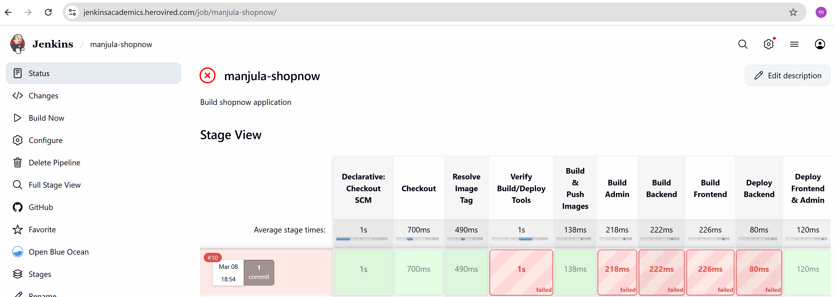

Error while running the shop now project in Jenkins:
1.aws not found
+ set -e
+ docker --version
Docker version 28.2.2, build 28.2.2-0ubuntu1~24.04.1
+ aws --version
/home/jenkins/agent/workspace/manjula-shopnow@tmp/durable-da5bc8ef/script.sh.copy: 4: aws: not found

- set -euxo pipefail
/home/jenkins/agent/workspace/manjula-shopnow@tmp/durable-f9b3451d/script.sh.copy: 2: set: Illegal option -o pipefail

The Jenkins agent uses /bin/sh (dash on Ubuntu), which doesn't support pipefail. Fixed this by using a bash shebang.

- Build Admin stage is failing

+ export DOCKER_CONFIG=/home/jenkins/agent/workspace/manjula-shopnow/.docker
+ DOCKER_CONFIG=/home/jenkins/agent/workspace/manjula-shopnow/.docker
/home/jenkins/agent/workspace/manjula-shopnow/admin@tmp/durable-81871844/script.sh.copy: line 4: IMAGE_TAG_EFFECTIVE: unbound variable

Able to Build and push usingas Jenkins, Since creation of EKS cluster is not supported as of now, deployment is pending for shopnow:

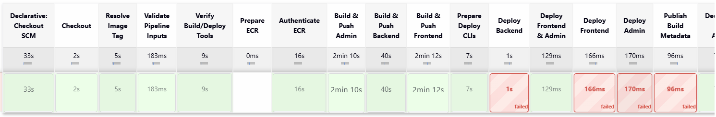

Kubernetes Resources (shopnow-demo namespace)
- Each service has: ClusterIP Service + Deployment + HPA (1-3 replicas) + ConfigMap
- Backend additionally has a Secret for MongoDB URI
- MongoDB runs as a StatefulSet with PersistentVolume (gp3)
Monitoring
- CloudWatch Agent DaemonSet → Container Insights metrics (CPU, memory, network)
- Fluent Bit DaemonSet → CloudWatch Logs
- 8 CloudWatch Alarms for CPU, memory, pod restarts, error rates

ChatOps Integration
aws sns publish \
--topic-arn "arn:aws:sns:us-east-1:975050024946:shopnow-builds" \
--subject "TEST: ShopNow Notification" \
--message "This is a test notification from ShopNow ChatOps setup." \
--region us-east-1

ShopNow - Verification Steps
How to verify that frontend, backend, admin, and database are functional and accessible after deployment.
Prerequisites
- `kubectl` configured with EKS access
- Kubeconfig generated:
```bash
aws eks update-kubeconfig --name manjula-eks-cluster-shopnow --region us-east-1
```
Step 1: Check Pods Are Running

```bash
kubectl get pods -n shopnow-demo -o wide
```

**Expected:** All pods show `STATUS: Running` and `READY: 1/1`
```
NAME READY STATUS RESTARTS
shopnow-backend-xxx 1/1 Running 0
shopnow-frontend-xxx 1/1 Running 0
shopnow-admin-xxx 1/1 Running 0
mongo-0 1/1 Running 0
```
Step 2: Check Services
```bash
kubectl get svc -n shopnow-demo
```
**Expected:**

| Service | Type | Port |
|------------|-----------|------|
| frontend | ClusterIP | 80 |
| backend | ClusterIP | 5000 |
| admin | ClusterIP | 80 |
| mongo-headless | ClusterIP (None) | 27017 |
Step 3: Check Ingress & Get External URL
```bash
kubectl get ingress -n shopnow-demo
```
**Expected:** Shows an `ADDRESS` column with the load balancer hostname.
Step 4: Test Backend Health (In-Cluster)

**Option A: Port-forward to localhost**

```bash
kubectl port-forward svc/backend 5000:5000 -n shopnow-demo
Then in another terminal:
```bash
curl http://localhost:5000/api/health
```
**Option B: Exec into a pod**

```bash
kubectl exec -it deploy/shopnow-frontend -n shopnow-demo -- wget -qO- http://backend:5000/api/health
**Expected:** JSON response like `{"status":"ok"}`
Step 5: Test Frontend (Port-Forward)
```bash
kubectl port-forward svc/frontend 3000:80 -n shopnow-demo

Open **http://localhost:3000** in your browser. You should see the ShopNow store page.
Step 6: Test Admin Panel (Port-Forward)
```bash
kubectl port-forward svc/admin 3001:80 -n shopnow-demo
Open **http://localhost:3001** in your browser. You should see the ShopNow admin dashboard.
Step 7: Test via Ingress (External Access)

Get the load balancer address:

```bash
INGRESS_URL=$(kubectl get ingress shopnow-ingress -n shopnow-demo \
-o jsonpath='{.status.loadBalancer.ingress[0].hostname}')
echo $INGRESS_URL
```
Test each endpoint:
```bash
Frontend — expected: 200
curl -s -o /dev/null -w "%{http_code}" http://$INGRESS_URL/aryan

Admin — expected: 200
curl -s -o /dev/null -w "%{http_code}" http://$INGRESS_URL/aryan-admin

Backend API health — expected: JSON response
curl http://$INGRESS_URL/aryan/api/health
```
**Or open in browser:**
- Frontend: `http://<INGRESS_URL>/aryan`
- Admin: `http://<INGRESS_URL>/aryan-admin`
Step 8: Verify MongoDB Connectivity

```bash
kubectl exec -it mongo-0 -n shopnow-demo -- mongosh --eval "db.adminCommand('ping')"
```
**Expected:** `{ ok: 1 }`
Step 9: Check HPA (Autoscaling)

```bash
kubectl get hpa -n shopnow-demo
```

**Expected:** Shows min/max replicas and current CPU utilization for backend, frontend, and admin.

---

Step 10: Check Pod Logs (Troubleshooting)

```bash
Backend logs
kubectl logs -l app=backend -n shopnow-demo --tail=50

Frontend logs
kubectl logs -l app=frontend -n shopnow-demo --tail=50

Admin logs
kubectl logs -l app=admin -n shopnow-demo --tail=50

MongoDB logs
kubectl logs mongo-0 -n shopnow-demo --tail=50
```

---

Quick All-in-One Verification Script

```bash
!/bin/bash
NS="shopnow-demo"

echo "=== Pods ==="
kubectl get pods -n $NS

echo ""
echo "=== Services ==="
kubectl get svc -n $NS

echo ""
echo "=== Ingress ==="
kubectl get ingress -n $NS

echo ""
echo "=== Backend Health (in-cluster) ==="
kubectl exec deploy/shopnow-backend -n $NS -- \
wget -qO- --timeout=5 http://localhost:5000/api/health 2>/dev/null || echo "FAIL"

echo ""
echo "=== Frontend Health (in-cluster) ==="
kubectl exec deploy/shopnow-frontend -n $NS -- \
wget -qO- --timeout=5 http://localhost/health 2>/dev/null || echo "FAIL"

echo ""
echo "=== Admin Health (in-cluster) ==="
kubectl exec deploy/shopnow-admin -n $NS -- \
wget -qO- --timeout=5 http://localhost/health 2>/dev/null || echo "FAIL"

echo ""
echo "=== MongoDB Ping ==="
kubectl exec mongo-0 -n $NS -- mongosh --quiet --eval "db.adminCommand('ping')" 2>/dev/null || echo "FAIL"

echo ""
echo "=== HPA Status ==="
kubectl get hpa -n $NS

echo ""
echo "=== All checks complete ==="
```

Save this as `verify.sh` and run:

```bash
chmod +x verify.sh
./verify.sh
```

---

Verification Checklist

| | Check | Command | Expected |
|---|-------|---------|----------|
| 1 | Pods running | `kubectl get pods -n shopnow-demo` | All `1/1 Running` |
| 2 | Services exist | `kubectl get svc -n shopnow-demo` | 4 services listed |
| 3 | Ingress has address | `kubectl get ingress -n shopnow-demo` | ADDRESS populated |
| 4 | Backend health | `curl localhost:5000/api/health` | `{"status":"ok"}` |
| 5 | Frontend loads | Browser → `localhost:3000` | ShopNow store page |
| 6 | Admin loads | Browser → `localhost:3001` | Admin dashboard |
| 7 | External frontend | `curl http://<LB>/aryan` | HTTP 200 |
| 8 | External admin | `curl http://<LB>/aryan-admin` | HTTP 200 |
| 9 | MongoDB ping | `mongosh --eval "db.adminCommand('ping')"` | `{ ok: 1 }` |
| 10 | HPA active | `kubectl get hpa -n shopnow-demo` | Shows targets |

